Corsair Plaza “Plaza” and Quik Wash “Laundromat”
Key Stats
Combined NOI: $40K ($1K Plaza, $39K Laundromat)
Year 1 Cash-On-Cash Return: 7% - 13%
Valuation
Plaza Cash-on-Cash Return Profile
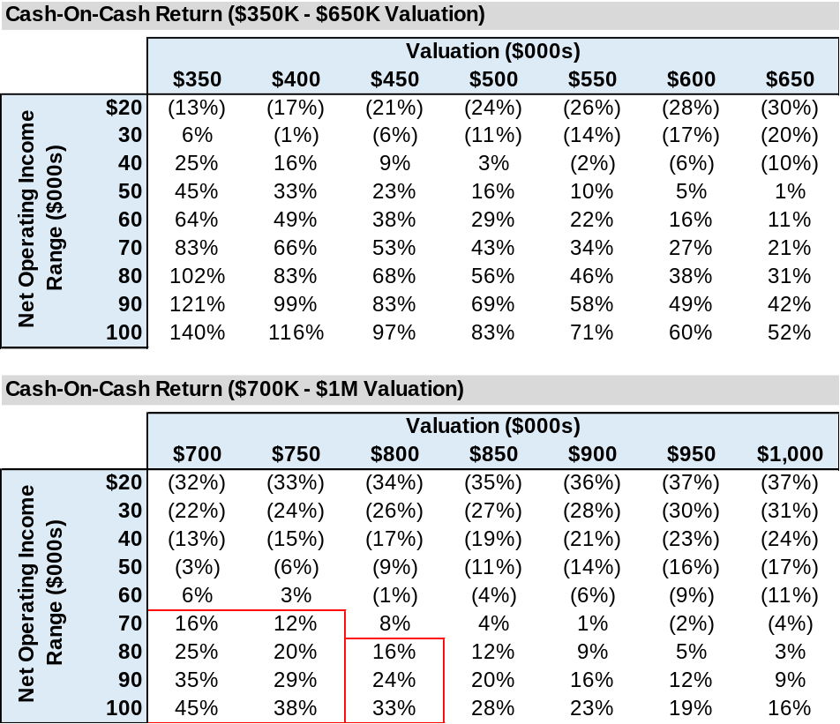

Using ServisFirst Bank’s quoted 6.50% interest rate, 85% LTV, and 20-year term, we arrive at a debt service capital cost of 8.95%. The tables above illustrate the cash-on-cash returns based on a range of valuations and post-debt-service NOI.

For example, if the property was appraised using $80K of NOI and a 10% cap rate, the resulting $800K valuation would result in a 16% cash-on-cash return.

However, if $80K of NOI was appraised using a cap rate of 8%, then the resulting $1M valuation would result in a 3% cash-on-cash return.

Calculate 10-year view of actual debt servicing and how this effects annual cash flow

